# EE101 Homework 2

Submit via Blackboard Due: Oct.24th

Your name: __________ Student ID: _________________

**Problem 1:**

X-ray is a penetrating form of high-energy electromagnetic radiation, whose wavelength ranges from 10 picometers to 10 nanometers. Among the wide wavelength spectrum, X-rays with wavelength below 0.2-0.1nm are called hard X-rays, while those with longer wavelength are called soft X-rays.

1. What is the relationship of X-ray’s energy ($E_{X}$), wavelength ($λ_{X}$) and frequency ($f_{X}$)
2. Given a hard X-ray with wavelength = 0.13 nm, what is its corresponding frequency and energy (in keV)? ($h=6.626*{10}^{-34}m^{2}kg s^{-1}, c=3 .000*{10}^{8}ms^{-1}, e=1.602*{10}^{-19}C$)
3. Given a soft X-ray with frequency = $3.846*{10}^{17} Hz$, what is its corresponding wavelength and energy (in keV)?
4. In medical imaging, X-ray with energy more than 60keV is often observed. Given an X-ray in medical imaging with energy = 69keV, what is its corresponding wavelength and frequency?
5. (Bonus) Why do hard and soft x-ray have much longer wavelength and smaller energy compared to medical x-ray, but still can be applied in detecting crystal structure with resolution of a few nanometer, while medical images can only achieve resolution of a few micrometer?

**Problem 2:**

1. Derived from Equation (1), derive both Equation (2) and (3).
$$∆λ=\frac{h}{m_{0}c}\left(1-cosθ\right) \left(1\right)$$

$$∆E=E_{X,inc}-E_{X,scat}=\frac{hc}{λ_{inc}}-\frac{hc}{λ_{scat}} (2)$$

$$E_{X,scat}=\frac{E_{X,inc}}{1+\left(\frac{E_{X,inc}}{mc^{2}}\right)\left(1-cosθ\right)} (3)$$

2. Given incident X-ray energy $E_{X,inc}=67keV$, (${m_{e}c}^{2}=511keV$), calculate the scatter energy $E_{X,scat}$ when $θ=0, 30°,60°, 90°$. Then plot $E_{X,scat}$ vs scatter angle.

**Problem 3:**

$6.5*{10}^{16}$ X-ray photons with energy of $50keV$ were incident into a $4cm$ thickness phantom, and finally reached the detector. The length of lead strip is 4cm and the separation of lead strip is 1cm. Assuming that Compton scattering will at most happen once during the travelling, and it can happen anywhere. Figure 1 shows several possibilities of X-ray propagation. Provided the linear attenuation of Phantom $4{cm}^{-1}$, calculate the energy range of X-ray which was detected by detector. (If you need any physical constant for the calculation, please refer to the course PPT)

*Figure 1*

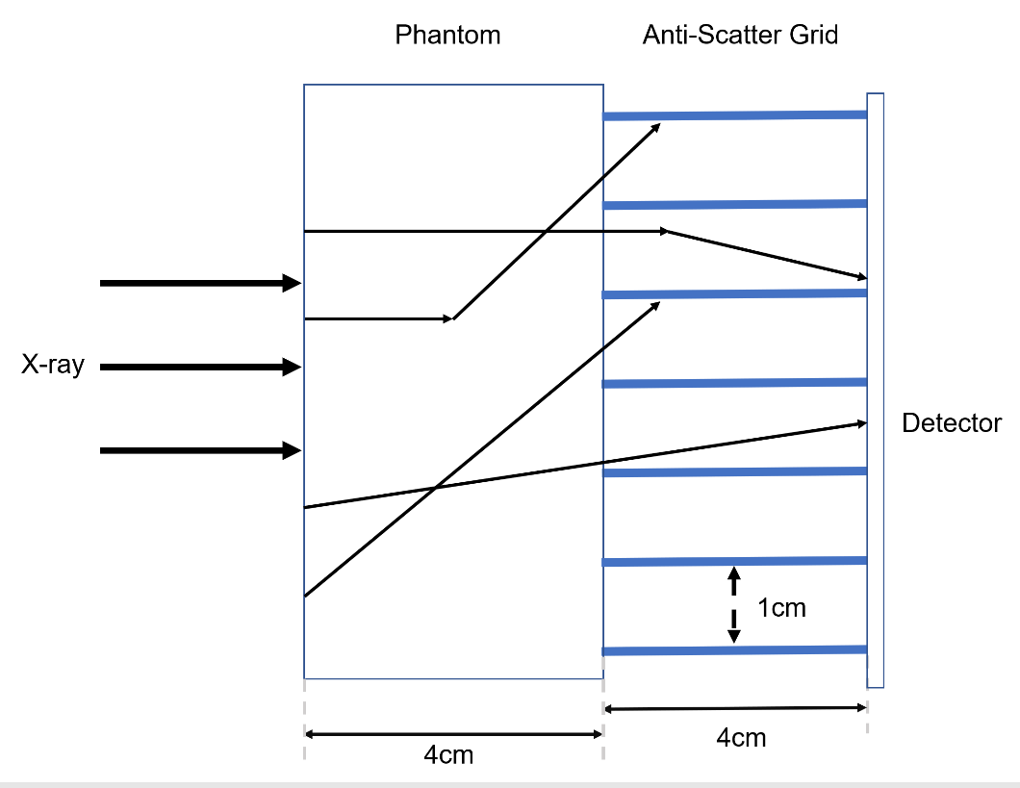

**Problem 4:**

Digital X-ray mammography is used to detect small tumors or microcalcifications in the breast and proves to be effective detection of breast cancer. In mammographic examinations, the upper plate keeps going down to compress the breast, as shown in the figure below. Answer the following with a brief explanation

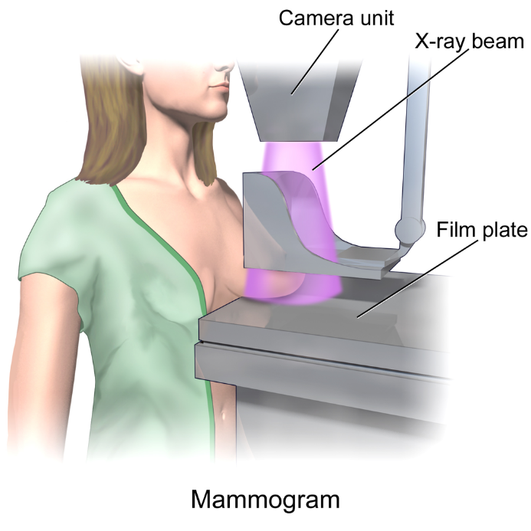

*Figure 2: Illustration of the compression during X-ray mammography (from Wikipedia)*

1. Will the spatial resolution become better or worse by compression? Why?
2. Will the image contrast become better or worse? Why
3. Is the required X-ray dose for a given image SNR higher or lower with compression?

**Problem 5:**

Compute the CT number of the following materials at X-ray energy $=50keV({cm}^{-1})$

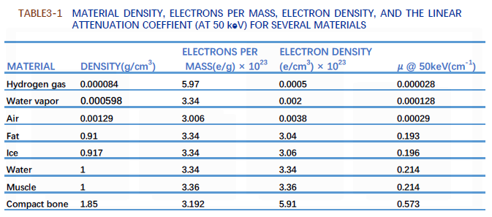

*Figure 3: Table from PPT-04, slide 26*

**Problem 6:**

For the object shown in Figure 4(a), assume that a darker area corresponds to an area of higher signal and the detailed geometry relationship is shown as in figure 4(b). Please answer the following questions.

1. Draw projections that would be acquired at angles $ϕ=0°, 45°, 90°, 135° and 180°$ (ignore beam hardening)
2. Sketch the sinogram for values of $ϕ$ from 0 to 180°.
3. Do back projection to the sinogram to reconstruct the image.

(*Hint: function radon() and iradon() can be used in this Problem*)

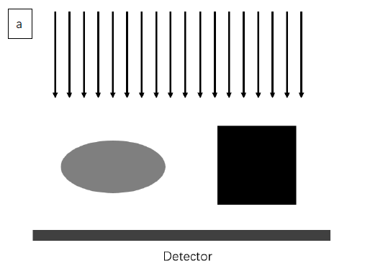

*Figure 4(a): Diagram of the object and the direction of X-ray*

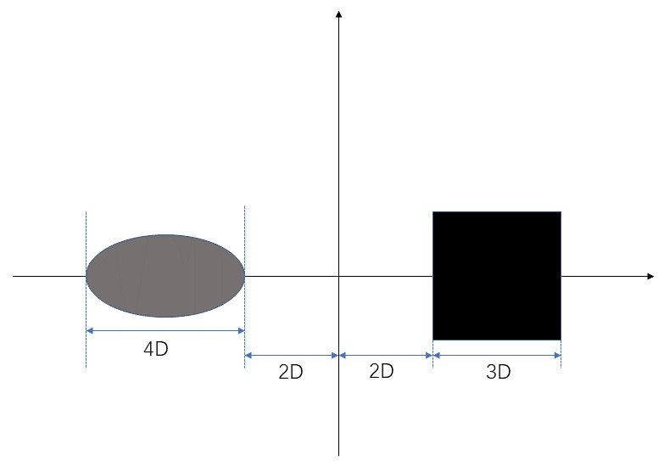

*Figure 4(b): Detailed geometric relation*